**Final Project Lab**

Brandon Trinkle

Information Technology, Arizona State University

IFT 320: Managing the Cloud

Professor Rahul Kashyap

10/7/2024

**Final Lab**

**Figure 1**

*A Screenshot of the two EC2 instances.*

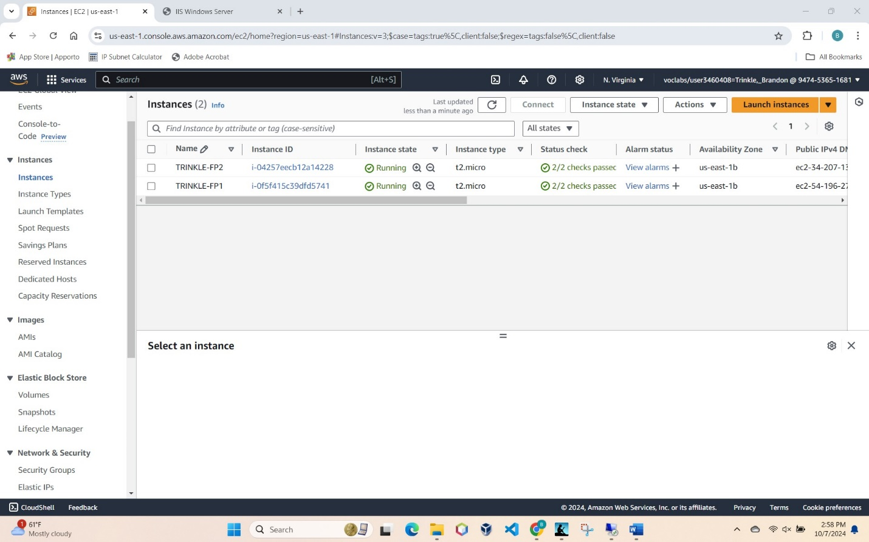

**Figure 2**

*Screenshot of the Security group*

**Figure 3** *Attaching the 5gb EBS storage to both instances*

**Figure 4**

*Screenshot of IIS webpage through Windows Server on the Remote Connection.*

**Figure 5**

*Screenshot of web page through load balancer*

**Figure 6**

*Unable to use route53*

**Figure 7**

*Screenshot of cloudwatch*

**Figure 8**

*Screenshot of DynamoDB table*

